Lab: JS Basic Syntax, Conditional Statements and Loops
Problems for in-class lab for the "Technology Fundamentals" course @ SoftUni .
Submit your solutions in the SoftUni judge system at: https://judge.softuni.bg/Contests/1189/Lab-Intro-and-Basic-Syntax

Multiply Number by 2
Write a function that receives a number and prints as result that number multiplied by two

Examples
Input | Output
2 | 4
5 | 10
20 | 40

Hints
Create a function called solve (or some other name). As parameters it will receive a number num.
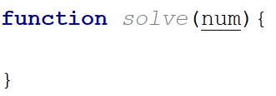
Print the result inside the function
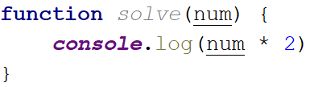
If you want to test your code locally, you need to call the function
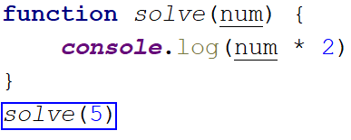

Excellent Grade
Write a function that receives a single number and checks if the grade is excellent or not.
If it is, print "Excellent", otherwise print "Not excellent"

Examples
Input | Output
5.50 | Excellent
4.35 | Not excellent

Hints
Check if the number given is greater or equal to 5.50 and print the corresponding result
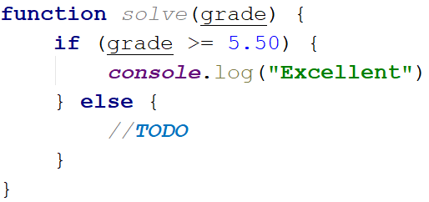

Numbers from 1 to 5
Create a function that prints all the numbers from 1 to 5 (inclusive) each on a separate line

Hints
Create a for loop starting from 1 and continuing until 5 and print the number
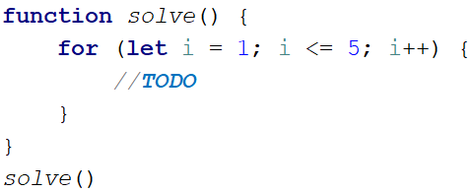

Numbers from N to 1
Create a function that receives a number N and prints all the numbers from N to 1. Try using while loop

Examples
Input | Output
5 | 5  4  3  2  1
3 | 3  2  1

Hints
Create a while loop with condition N >= 1. Print N and decrease it with each step
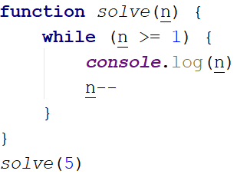

Numbers from M to N
Write a function that receives a number M and a number N (M will always be bigger than N). Print all numbers from M to N

Examples
Input | Output
6  2 | 6  5  4  3  2
4  1 | 4  3  2  1

Hints
Use for or while loop and print the numbers.
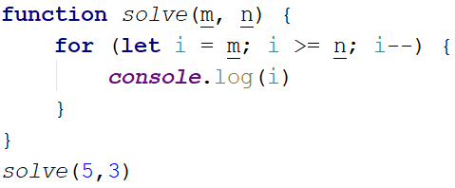

Student Information
You will be given 3 parameters – student name (string), age (number) and average grade (number). Your task is to print all the info about the student in the following format. The grade should be formatted to the second decimal point:
"Name: {student name}, Age: {student age}, Grade: {student grade}".

Examples
Input | Output
'John', 15, 5.54678 | Name: John, Age: 15, Grade: 5.55
'Steve', 16, 2.1426 | Name: Steve, Age: 16, Grade: 2.14
'Marry', 12, 6.00 | Name: Marry, Age: 12, Grade: 6.00

Hint
Use toFixed() method to format the grade.
- First receive the input:
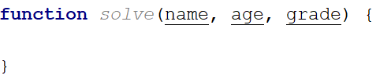
- Print the output:

Month Printer
Write a program, which takes an integer from the console and prints the corresponding month. If the number is more than 12 or less than 1 print "Error!"

Input
You will receive a single number.

Output
If the number is within the boundaries print the corresponding month, otherwise print "Error!"

Examples
Input | Output |  | Input | Output
2 | February |  | 13 | Error!

Foreign Languages
Write a program, which prints the language, that a given country speaks. You can receive only the following combinations: English is spoken in England and USA; Spanish is spoken in Spain, Argentina and Mexico; for the others, we should print "unknown".

Input
You will receive a single country name.

Output
Print the language, which the country speaks, or if it is unknown for your program, print "unknown".

Examples
Input | Output |  | Input | Output
USA | English |  | Germany | unknown

Hint
Think how you can merge multiple cases, in order to avoid writing more code than you need to.

Theatre Promotions
A theatre is doing a ticket sale, but they need a program to calculate the price of a single ticket. If the given age does not fit one of the categories, you should print "Error!". You can see the prices in the table below:
Day / Age | 0 <= age <= 18 | 18 < age <= 64 | 64 < age <= 122
Weekday | 12$ | 18$ | 12$
Weekend | 15$ | 20$ | 15$
Holiday | 5$ | 12$ | 10$

Input
The input comes in two parameters. The first one will be the type of day (string). The second – the age of the person (number).

Output
Print the price of the ticket according to the table, or "Error!" if the age is not in the table.

Constraints
- The age will be in the interval [-1000…1000].
- The type of day will always be valid.

Examples
Input | Output |  | Input | Output |  | Input | Output
'Weekday',  42 | 18$ |  | 'Holiday', -12 | Error! |  | 'Holiday', 15 | 5$

Divisible by 3
Write a program, which prints all the numbers from 1 to 100, which are divisible by 3. You have to use a single for loop. The program should not receive input.

Sum of Odd Numbers
Write a program that prints the next n odd numbers (starting from 1) and on the last row prints the sum of them.

Input
You will receive a number – n. This number shows how many odd numbers you should print.

Output
Print the next n odd numbers, starting from 1, separated by new lines. On the last line, print the sum of these numbers.

Constraints
- n will be in the interval [1…100]

Examples
Input | Output |  | Input | Output
5 | 1  3  5  7  9  Sum: 25 |  | 3 | 1  3  5  Sum: 9

Multiplication Table
You will receive a number as an input from the console. Print the 10 times table for this number. See the examples below for more information.

Output
Print every row of the table in the following format:
{number} X {times} = {product}

Constraints
- The number will be an integer will be in the interval [1…100]

Examples
Input | Output |  | Input | Output
5 | 5 X 1 = 5  5 X 2 = 10  5 X 3 = 15  5 X 4 = 20  5 X 5 = 25  5 X 6 = 30  5 X 7 = 35  5 X 8 = 40  5 X 9 = 45  5 X 10 = 50 |  | 2 | 2 X 1 = 2  2 X 2 = 4  2 X 3 = 6  2 X 4 = 8  2 X 5 = 10  2 X 6 = 12  2 X 7 = 14  2 X 8 = 16  2 X 9 = 18  2 X 10 = 20

